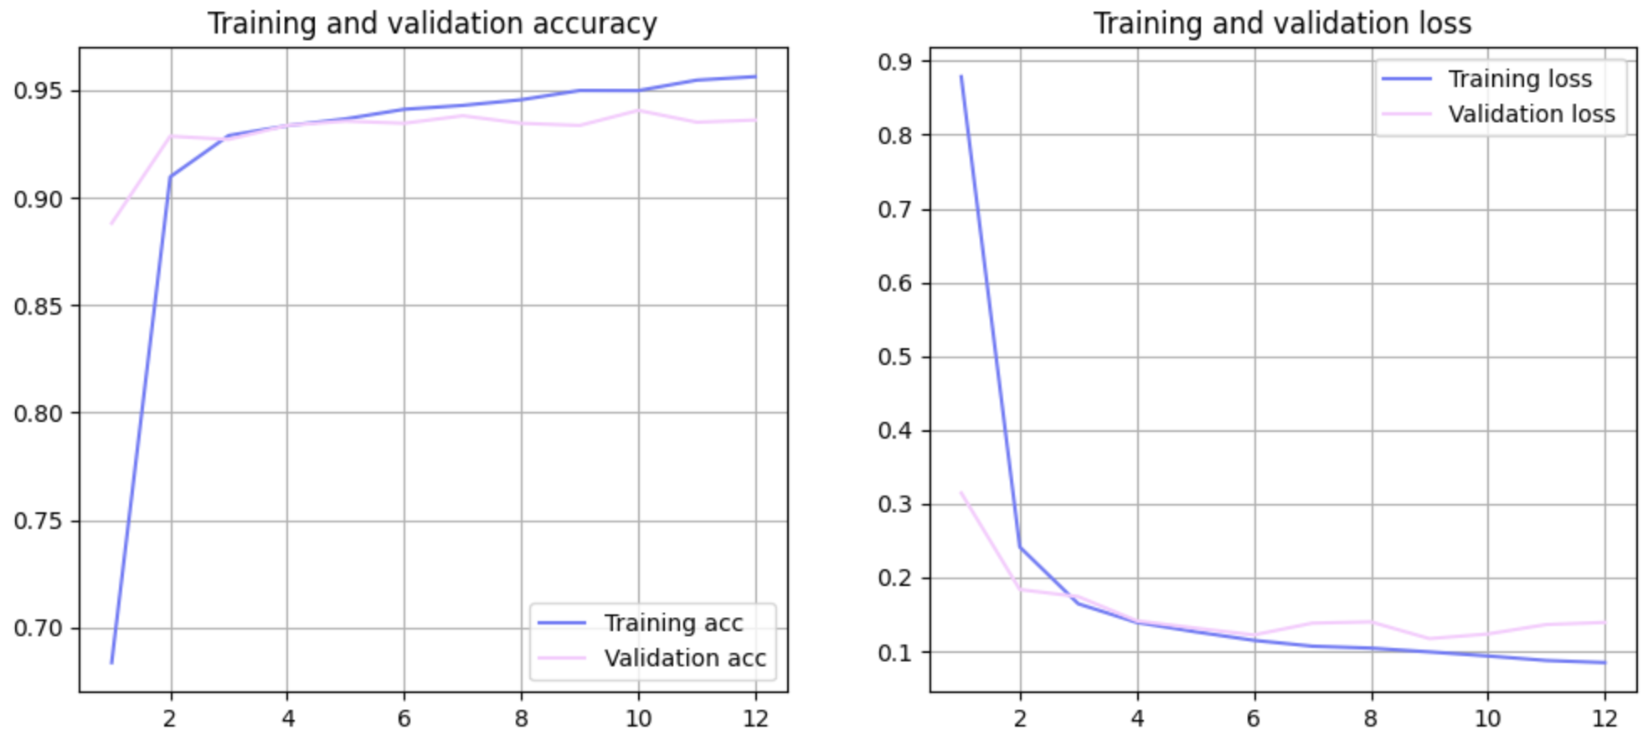

Batch size: 8 Epoch: 20

Dense: 6 Learning rate: 1e-5

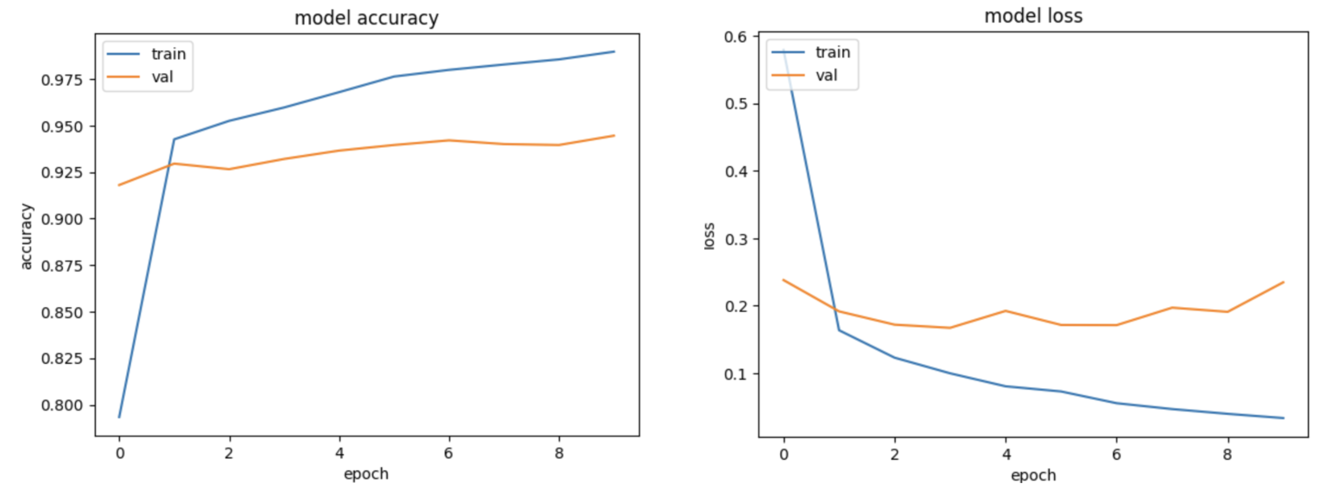

Batch size: 100 Epoch: 10

Dense: 6 Learning rate: 1e-5